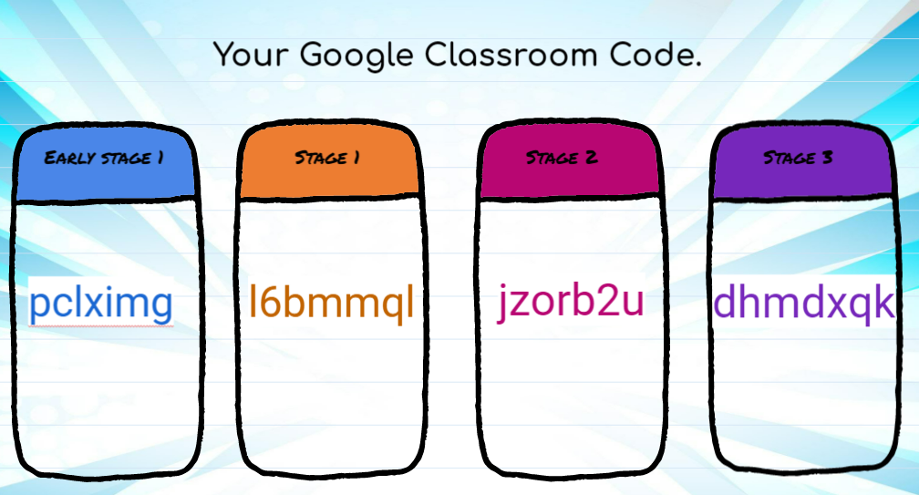

Daily Zoom Meeting Schedule
Stage | Time of Zoom Meeting | Teacher
Early Stage 1 | 9:00 am | Mrs. Anderson
Stage 1 | 9:20 am | Miss Betteridge/Mrs. McCabe
Stage 2 | 9:40 am | Mr. Wootton
Stage 3 | 10: 00 am | Miss Stone

What you will need to login to Google Classroom
- Log in to the DET portal (student account, most students will know how to do this).
- Sign in with your school email. For example, username@education.nsw.gov.au using the password 123
- Select Classroom.
- Join a class by clicking the + symbol.
- Enter the code and click Join (see codes on the following page).

Alternative login to Google Classroom
- Go to classroom.google.com and click Sign In.
- Sign in with your school email. For example, username@education.nsw.gov.au using the password 123
- On the Classes page, click Add. Join class.
- Enter the code and click Join (see codes on the following pages).

Expectations for Online Learning
- Log into Google Classroom.
- Sign in to the daily attendance form.
- Attend the daily zoom meeting.
- Work through activities following the suggested timetable.
- If you are stuck, leave a question for a teacher in the assignment comments section or contact your teacher on class dojo. Your teacher will respond as soon as they can (please keep in mind that this may not be your class teacher).
- Once complete, submit your assignments for your teacher to check by selecting ‘Mark as Done’ or ‘Hand In’.
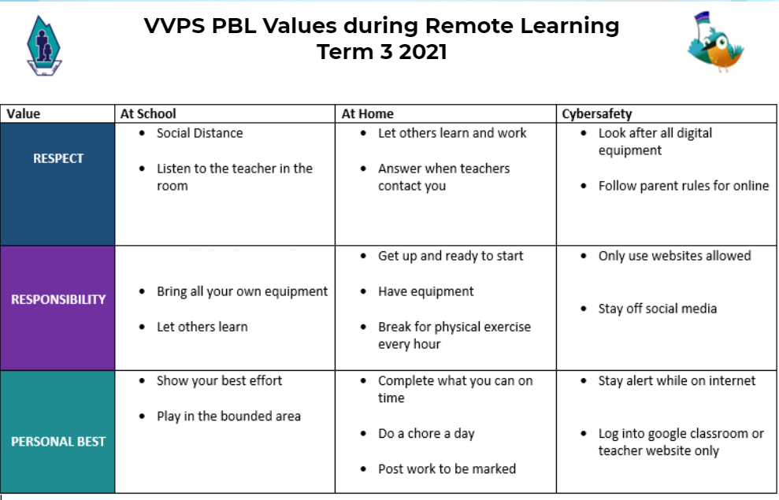

Daily Model for Learning from Home as per Department of Education Guidelines

Session | ES1 | S1 | S2 | S3
Morning | English  45-60 minutes | English  45-60 minutes | English  45-60 minutes | English  45-60 minutes
Middle | Maths  30 -45 minutes | Maths  30 -45 minutes | Maths  30 -45 minutes | Maths  30 -45 minutes
Afternoon | Other KLA’s  30 - 60 minutes | Other KLA’s  30 - 60 minutes | Other KLA’s  1 - 1.5 hours | Other KLA’s  1 - 1.5 hours
Total Hours per day | 2.5 Hours | 2.5 Hours | 3 Hours | 3 Hours

